Intro to Deep Learning

Assignment 4

The results obtained for training and testing the LeNet model on the CIFAR10 dataset is shown below:

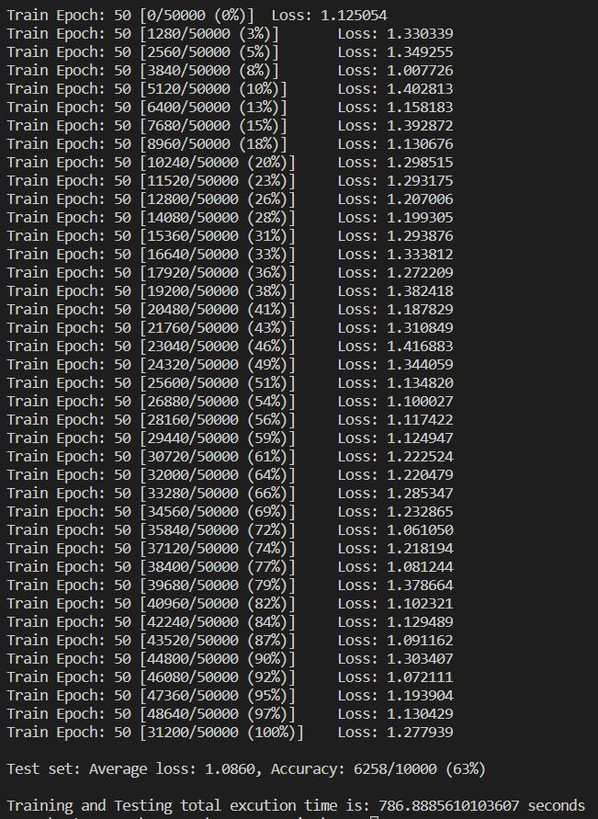

On adding a dropout layer to the model, the results obtained on training and testing the model is shown below:

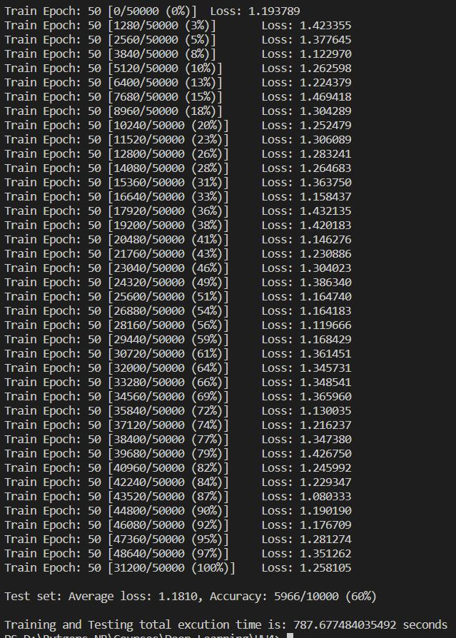

Finally, on adding a batch normalization layer to the model, the results obtained on training and testing the model is shown below:

